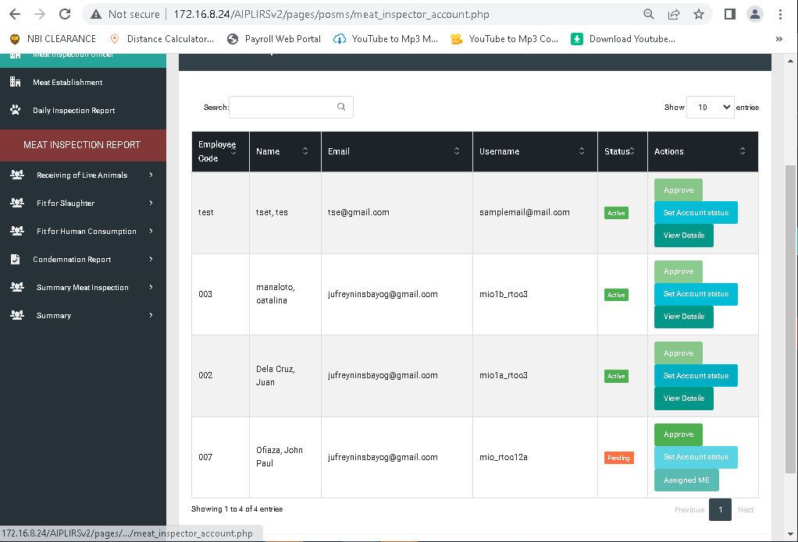

set Account status activated not functioning and remove approve button if account status is active

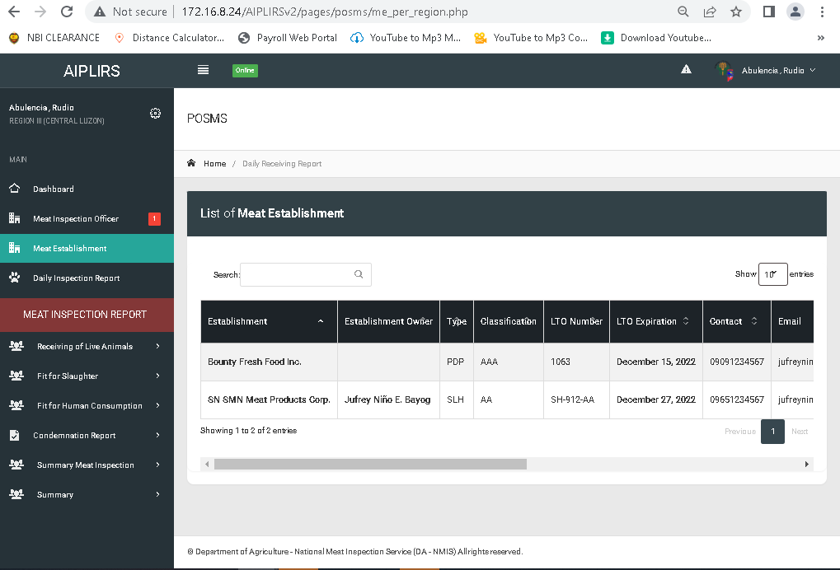

Table header

Establishment to Meat establishment

Region to province

Remove colum

establishment owner

contact

email

address

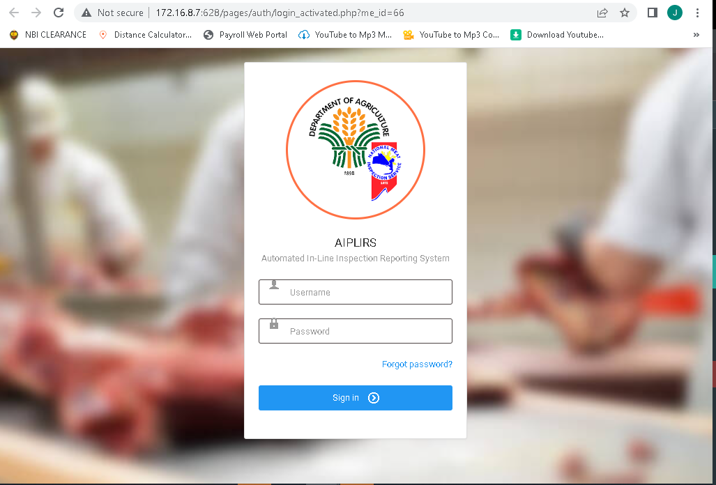

Input table icon move up

Aiplirs naming AUTOMATED IN-PLANT LINE INSPECTION REPORTING SYSTEM

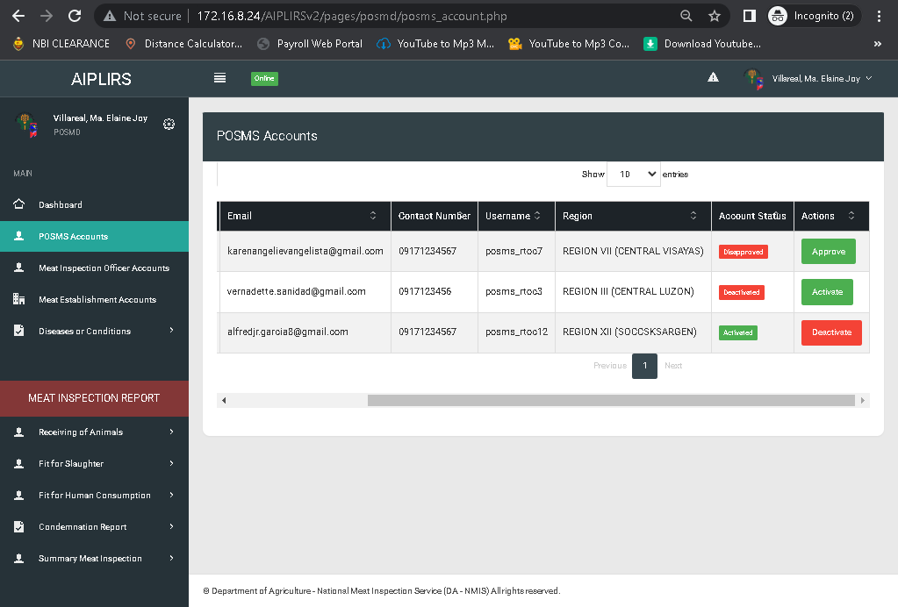

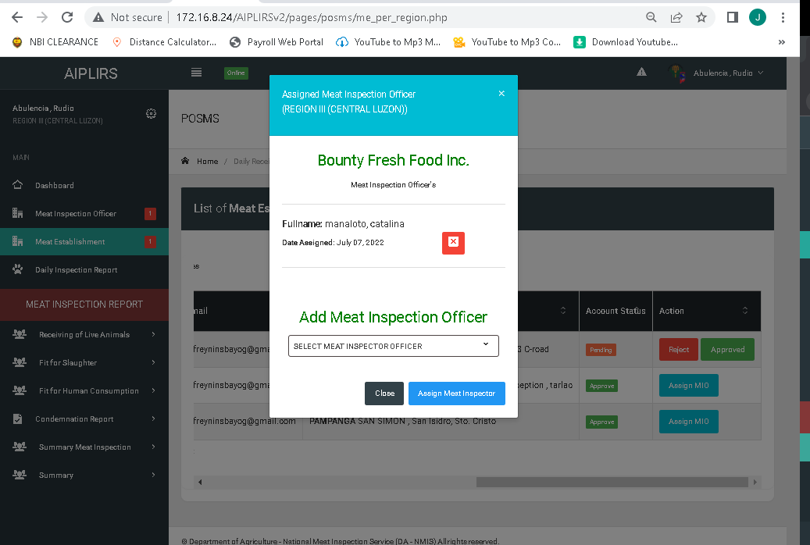

Remove make it text

Remove close button

Remove region data on